Assessment Schedule – 2015

Chemistry: Demonstrate understanding of the properties of organic compounds (91391)

Evidence Statement
Q | Evidence | Achievement | Merit | Excellence
ONE  (a) | 1. Carboxylic acid or carboxyl 2. Amine or aminoalkane  3. Amide 4. Ester | - Three correct.  - Two correct.
(b) | 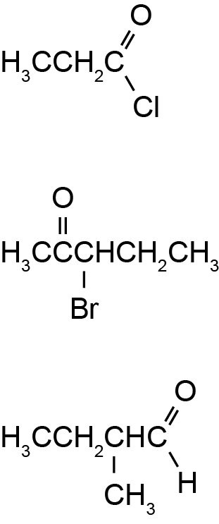 | - Three correct.  - Two correct.

(c)(i) | Primary H₃C–CH₂–CH₂–CH₂–Cl or H₃C–CH₂–CH(CH₃)–Cl  Secondary H₃C–CH(Cl)–CH₂–CH₃  Tertiary H₃C–CCl(CH₃)CH₃ | - Two isomers correct.  (Classification not required.)  - Identifies two products.  - Elimination.  - Identifies major and minor products. | - All isomers correctly drawn and classified.  - Identifies three products.  AND  Explains elimination (with reference to adjacent carbon atoms).  - TWO products because of asymmetry.  - Identifies and explains major and minor products in terms of Saytzeff’s rule. | - Fully elaborates on the elimination reactions for all three haloalkanes.  (Note: Minor error or omission E.g. Cis/trans omitted – E7).
(ii) | Cl–CH₂–CH₂–CH₂–CH₃ → H₂C=CH–CH₂–CH₃  H₃C–CH(Cl) –CH₂–CH₃ → two possibilities:  1. Minor H₂C=CH–CH₂–CH₃ but-1-ene  2. Major H₃C–CH=CH–CH₃ cis but-2-ene and trans but-2-ene (in equal quantities).  H₃C –CCl(CH₃)CH₃ → C(CH₃)(CH₃)=CH₂  All reactions are ELIMINATION reactions as the Cl functional group and the hydrogen atom from the adjacent carbon atoms are removed.  (The molecule changes from saturated to unsaturated).  The secondary haloalkane produces major and minor products because the molecule is asymmetric OR it has two adjacent C atoms with different numbers of H atoms attached.  The major product is formed when the H atom is removed from the adjacent C atom with the fewest H atoms attached,  OR the major product has the most substituted double bond.

NØ | N1 | N2 | A3 | A4 | M5 | M6 | E7 | E8
No response or no relevant evidence | 1a | 2a | 4a | 5a | 2m | 3m | 1e with minor error / omission | 1e

Q | Evidence | Achievement | Achievement with Merit | Achievement with Excellence
TWO  (a)(i)  (ii) | A chiral compound contains a carbon atom with 4 different groups attached.  Same – boiling point / melting point / density / solubility.  Different – enantiomers rotate plane-polarised light in different directions. | - ONE correct. | - BOTH correct.
(b) | 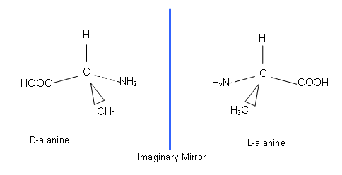 | - One correct 3-D image.  OR  BOTH isomers drawn but an error in the way the groups are connected to asymmetric carbon. | - Both enantiomers correct.
(c)(i)  (ii)  (iii)  (iv) | 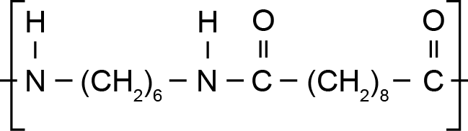  This is condensation or substitution (polymerisation), whereby the two monomers are joined together and a small molecule (HCl(g)) is released.  Each monomer is di-functional or has a reactive site at each end (allowing polymerisation to be ongoing.)  The sebacoyl chloride (as an acyl chloride) reacts vigorously with water forming the carboxylic acid, (however, it does not react with the non-polar solvent.)  Dilute acid will cause hydrolysis of the amide linkage.  The products formed would be (di)ammonium salt or ⁺H₃N(CH₂)₆NH₃⁺  and the (di)oic acid. HOOC(CH₂)₈COOH  (Names not required) | - Identify the repeating unit of the polymer formed.  - Identifies condensation.  OR  Identifies small molecule or HCl formed.  OR  Identifies both monomers have reactive sites or functional groups at each end.  - Sebacoyl chloride reacts with water.  - Hydrolysis.  OR  One functional group | - Explains condensation polymerisation.  - Hydrolysis  AND  Identifies one functional group produced (could be amine). | - Fully explains the reaction occurring.  (Note: Minor error or omission, e.g. amine or sebacoyl chloride reaction with water - E7).

NØ |  | N1 | N2 | A3 |  | A4 | M5 |  | M6 | E7 |  | E8
No response; no relevant evidence |  | 1a | 2a | 3a |  | 4a | 2m +1a |  | 3m | 1e with minor error / omission |  | 1e
Q | Evidence |  |  |  | Achievement |  |  | Achievement with Merit |  |  | Achievement with Excellence
THREE  (a)(i) | Any one of these groups circled:  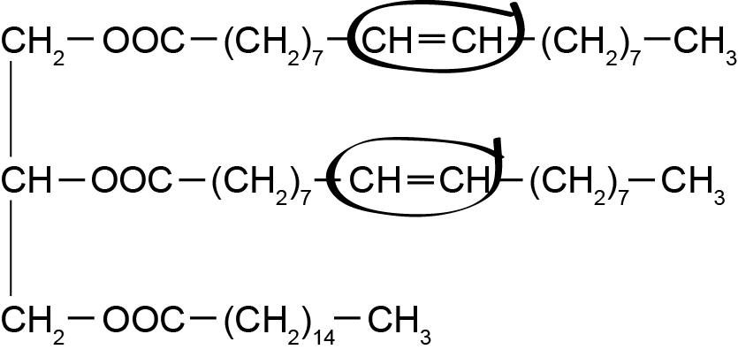 |  |  |  | - Functional group correct.
(ii) | Bromine water rapidly decolourised from red or orange to colourless in an addition reaction.  OR  Acidified permanganate rapidly decolourised from purple to colourless in a redox or oxidation or reduction reaction. |  |  |  | - Incomplete description. |  |  | - Links the observation to the reaction type.
(iii) | 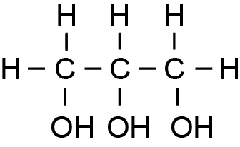  NaOOC(CH₂)₇CH=CH(CH₂)₇CH₃  NaOOC(CH₂)₁₄CH₃ |  |  |  | - ONE product correct. |  |  | - ALL products correct.
(iv) | Increases the rate of reaction;  (Condensing) prevents volatile chemicals from being lost to the environment,  (The mixture refluxed to increase reaction rate without loss of product through evaporation). |  |  |  | • Partial explanation. |  |  | - Full explanation given.
(b) | Structures  A = CH₃CH₂CH₂NH₂  B = CH₃CH₂CH₂OH  C = CH₃CH₂CHO OR CH₃CH₂COOH  D = CH₃CH₂COOCH₂CH₃  E = CH₃CH₂COCl  Reagents  1 = NaOH(aq) OR KOH(aq)  2 = Cr₂O₇^{2–} / H⁺ or MnO₄– / H⁺  3 = NaBH₄ OR LiAlH₄  4 (i) = CH₃CH₂OH or ethanol  4 (ii) = concentrated H₂SO₄  5 = NH₃ (alcoholic / gas / conc). |  |  |  | - Any THREE correct structures.  - Any THREE correct reagents. |  |  | - Any EIGHT correct structures / reagents. |  |  | - ALL structures and reagents correct.  (Note: One error or omission – E7).

NØ | N1 | N2 | A3 | A4 | M5 | M6 | E7 | E8
No response; no relevant evidence | 1a | 2a | 3a | 5a | 2m | 3m | 1e (one error ) + 1m | 1e + 1m

Cut Scores
Not Achieved | Achievement | Achievement with Merit | Achievement with Excellence
0 – 7 | 8 – 13 | 14 – 18 | 19 – 24

